Communicating by E-mail

Options,Tips and E-mail Platform Assessment

Creating effective communication by e-mail takes some planning. First you have to build a list.
- Ask to use the MSA’s existing list if they have already secured consent from members to send out general news and information affecting Medical Staff.
- Build your own list by passing out a sheet to gather emails from physicians at Department meetings and Facility Engagement meetings. Inform them of what they can expect to receive by e-mail. (e.g. updates and invitations, no spam).

Below is sample content for a hand-out sheet and opt-in process.

The new MSA physician society is requesting to e-mail you from time to time with:
- updates about Facility Engagement activities and progress at the hospital
- invitations to physician events about Facility Engagement
- opportunities to help shape our priorities for funding and activities through surveys or feedback.
- Indicate YES if you agree to receive e-mails ________
- What is your preferred e-mail address for this purpose? _______

Effective e-mail content
Communicating by e-mail won’t be 100% effective overnight. Not all physicians can/will open their e-mails and it will take time to build trust and interest in Faciity Engagement. Recipients may be more inclined to open e-mails if:
- The e-mail comes from a trusted source – a physician lead, department head or colleague
- The subject line is relevant to their needs
- Content is very short, preferably in bullet form, and in plain language (no jargon) so they don’t have to interpret
- The content links to, or attaches longer content they can read if interested in more information
- With any kind of ‘ask’ (for feedback, for example) the expectations are easy to understand so they know what they have to do, why, and when.

E-mail distribution options

If you are manually sending e-mails, it is preferable to send in the body of the e-mail window so physicians do not have to open attachments.

You can also subscribe to online services to send your e-mails that provide feedback and analytics about the effectiveness of your e-mail communication: you can see who has opened it or not, what e-mails are bouncing, and what links are the most popular.

Campaign Monitor (used by Doctors of BC groups and Divisions) and Constant Contact are cloud-based services to which you subscribe on a monthly basis for a reasonable cost. They enable you to send e-mails in bulk, and issue surveys and event invitations for an extra cost. You can add names by cutting and pasting in the addresses into the web-based window, or importing an EXCEL CSV file; and then update the list as needed. These are quite user-friendly to set up. You can try a free version before making your purchase.

MailChimp is another platform often used because it is free of charge for some templates and functions. However, the Doctors of BC Technology Office has listed some privacy concerns below for your consideration.
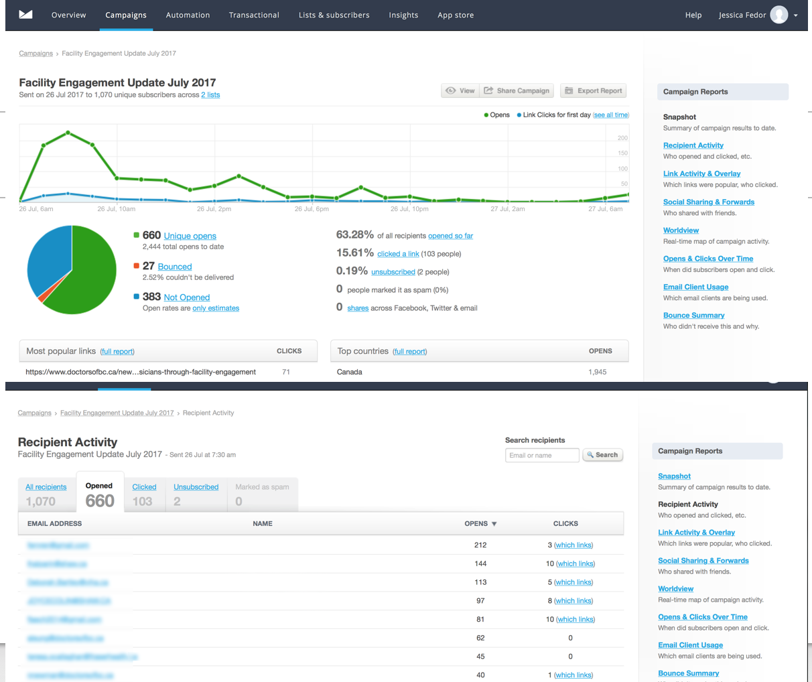

Doctors of BC - E-mail Platform Assessment
*Created to advise Divisions of Family Practice

Campaign Monitor – preferred option used by Doctors of BC/ Divisions

Why Campaign Monitor?
- Reasonable cost.
- Integration with a variety of other tools.
- Used by Doctors of BC. More internal expertise and support.
- Passed the Privacy Impact Assessment (for Doctors of BC/ Divisions of Family Practice)
- Positive feedback from Divisions and partners who have used the tool.
- Enterprise model with central administrator and multiple organization accounts.

E-mail Marketing Tool Comparison
This is not an exhaustive list of appropriate email marketing platforms, but tools that are broadly known.

 | Campaign Monitor | Constant Contact | MailChimp
Passes preliminary Privacy Impact Assessment | ✓ | ✓ |   SEE BELOW
Integrates with…  (note: you’ll want to assess the privacy impact of any software integration) | Drupal, Twitter, Facebook, Outlook, Microsoft Dynamics, Google Docs, Google Analytics, EventBrite, PayPal, and more. | Facebook, Hootsuite, Microsoft Dynamics, Quickbooks Online, Wordpress, Joomla, Drupal, and more.
Approx cost | Starts at $9 USD per month for 2500 users, and cost goes up depending on functionality you want, email volume, and additionl costs for plug-ins | Starts at$20 USD / month for 0-500 contacts, $40 / month for 501-2500 contacts. Additional if you want to add integrated event marketing and surveys.
Cost of agency or other shared license | 15% discount for non-profits. | 30% discount for non-profits.
Key pros | Quick and easy to get started.  Designed specifically for agencies  Provides tools for more than email  Doctors of BC uses. | Extensive training options.  Quick and easy to get started.  Provides tools for more than email
Key cons | Limited integration with social media (but may not be needed). | Limited integration with social media. (but may not be needed).
Campaign analytics | ✓yes | ✓✓yes
Event RSVP tracking | Available through a  plug-in at an extra cost.  Click here | Integrated – adds to subscription cost.
Surveys | Integrated for an extra cost (but may offer a free version) – click here | Integrated – adds to subscription cost.
Upload contacts list | ✓yes | yes✓

MailChimp: Not Recommended

MailChimp
While MailChimp is a popular email marketing tool, with free account options, it is not recommended for privacy reasons. The Areas of concern in their policies are highlighted below.

- 5. Information We Collect
  - Web Beacons: When we send emails to Members, we may track behavior such as who opened the emails and who clicked the links. We do that to measure the performance of our email campaigns and to improve our features for specific segments of Members. To do this, we include single pixel gifs, also called web beacons, in emails we send. Web beacons allow us to collect information about when you open the email, your IP address, your browser or email client type, and other similar details. We also include Web Beacons in the emails we deliver for you. We use the data from those Web Beacons to create the reports about how your email campaign performed and what actions your Subscribers took. Reports are also available to us when we send email to you, so we may collect and review that information.
  - Information from Other Sources: We may get more information about you or your Subscribers, like name, age, and use of social media websites, by searching the internet or querying third parties (we’ll refer to that information as Supplemental Information).
We use Supplemental Information to develop features like Social Profiles, a tool that helps you learn about your Subscribers and send them more relevant content.

- 6. Use and Disclosure of Your Personal Information
We may use and disclose your Personal Information only as follows:
  - To promote use of our Services. For example, if you leave your Personal Information when you visit our Website and don’t sign up for any of the Services, we may send you an email asking if you want to sign up. And if you use any of our Services and we think you might benefit from using another Service we offer, we may send you an email about it. You can stop receiving our promotional emails by following the unsubscribe instructions included in every email we send.
  - To send you informational and promotional content that you may choose (or “opt in”) to receive. You can stop receiving our promotional emails by following the unsubscribe instructions included in every email.
  - To bill and collect money owed to us. This includes sending you emails, invoices, receipts, notices of delinquency, and alerting you if we need a different credit card number. We use third parties for secure credit card transaction processing, and we send billing information to those third parties to process your orders and credit card payments. To learn more about the steps we take to safeguard that data, see Section 12 below.
  - To send you System Alert Messages. For example, we may let you know about temporary or permanent changes to our Services, like planned outages, new features, version updates, releases, abuse warnings, and changes to our Privacy Policy.
  - To communicate with you about your account and provide customer support.
  - To enforce compliance with our Terms of Use and applicable law. This may include developing tools and algorithms that help us prevent violations.
  - To protect the rights and safety of our Members and third parties, as well as our own.
  - To meet legal requirements like complying with court orders, valid discovery requests, valid subpoenas, and other appropriate legal mechanisms.
  - To provide information to representatives and advisors, like attorneys and accountants, to help us comply with legal, accounting, or security requirements.
  - To prosecute and defend a court, arbitration, or similar legal proceeding.
  - To provide, support, and improve the Services we offer. This includes aggregating information from your use of the Services and sharing such Aggregated Information with third parties.
  - To provide suggestions to you. This includes adding features that compare Members’ email campaigns, or using data to suggest other publishers your Subscribers may be interested in.
  - To transfer your information in the case of a sale, merger, consolidation, liquidation, reorganization, or acquisition. In that event, any acquirer will be subject to our obligations under this Privacy Policy, including your rights to access and choice. We’ll notify you of the change either by sending you an email or posting a notice on our Website.

- 7. Data Collected for and by our Users.
As you use our Services, you may import into our system personal information you’ve collected from your Subscribers. We have no direct relationship with your Subscribers, and you’re responsible for making sure you have the appropriate permission for us to collect and process information about those individuals. We may transfer personal information to companies that help us provide our Services (“Service Providers.”) All Service Providers enter into a contract with us that protects personal data and restricts their use of any personal data in line with this policy. As part of our Services, we may use and incorporate into features information you’ve provided or we’ve collected about Subscribers as Aggregate Information. We may share this Aggregate Information, including Subscriber email addresses, with third parties in line with the approved uses in Section 6.

Privacy Considerations
Links
Canada’s Anti-Spam Legislation (CASL)
Personal Information Protection Act (PIPA)

Does my email marketing tool need to be located in Canada?
Currently, there is no requirement in PIPA for data related to email marketing to be hosted in Canada. According to the Office of the Information and Privacy Commissioner for B.C., new legislation is being considered which extends some privacy safeguards to third party use of data by recommending that PIPA be amended to provide that:

a) organizations are responsible for the personal information they transfer to a third party for processing or for providing services to or on behalf of the transferring organization; and

b) organizations must use contractual or other means to ensure compliance with PIPA, or to provide a comparable level of protection, for personal information they transfer to a third party for processing or for providing services to or on behalf of the transferring organization.

2016 CRTC CASL Guidance on Record Keeping
Under CASL, the onus is on senders of commercial electronic messages (CEMs) to prove consent to send each message. In addition, the CRTC provides guidance on what senders of CEMs should consider keeping a hard copy or an electronic record of, including:
- all evidence of express and implied consent (e.g. audio recordings, copies of signed consent forms, completed electronic forms) from consumers who agree to receive CEMs;
- documented methods through which consent was collected;
- policies and procedures regarding CASL compliance; and
- all unsubscribe requests

